Final Report – “PopApp”

1.Abstract

Through this report I will provide an overview of what this project consists of, what the main target audience is and what the goal of this application really is. Furthermore, I will provide a brief insight of how the application will behave and what it’s functionalities are.

In addition, I will compare my application with other applications available on Google Play and at the end I will describe the tech used to achieve this project by providing a meaningful use case diagram and brief explanations of how the tech itself is used. I will also provide references at the end.

2.Goal and potential users

In this world and age many people are more and more only focused on their social state on the so called social networks developed by those big tech companies.

As such, more and more people tend to be very active on those networks, constantly trying to stand out (most of them) compared to other people.

The problem, in general, is that many people don’t know how to measure how popular or how good they are doing on those social networks (unless those people have a manager, but many amateurs don’t). That’s where this application comes in to play in favor of this type of user.

The goal of this project as many other projects of this kind is to trigger the awareness of people using social media services about their popularity and how they can improve on it.

The target audience of this application is represented by people that are famous or want to become famous and that need detailed data about their popularity on each social media supported by this application.

3.Introduction

This application will help the target audience query and display their data from the social media accounts supported and plot it on different types of charts, such as a column chart, a pie chart and a tag cloud chart.

The supported social media platforms this application currently has are Facebook and Twitter, with the ability to query comments and likes from each platform and display it in multiple types of charts like stated above.

Furthermore the application will give the user the ability to customize many features such as what the chart shown in the Home activity is. Another feature this application will have is the ability to download as an image any of those three types of charts.

From a visual point of view, the application will have a four color palette with it’s main and predominant colors being light green and light gray. The application mainly adopts a “round corner” style to encapsulate the the layouts and to give the user a more pleasing experience visually.

The user will be able to navigate between three screens within the application, those screens being: the home screen, the charts view screen and the settings/login screen, each serving a well defined purpose.

4.State of art

At the moment of writing this report, there are several applications available on Google Play that come near this project but have some drawbacks associated with them.

One application is named “Hootsuite: for Twitter & Insagram” [1] developed by the company with the same name, “Hootsuite”. For now, all I can say about researching and using this application for a while is that it misses on many of the features my application implements, features I will discuss in the next section.

One of the big missing feature of this application is that it lets you see a wall of your posts from a selected social media but it doesn’t give you any insight of how well you are doing compared to others or your past self.

Another very important drawback of this “Hootsuite” application is the fact that, after adding one social media to it, it becomes a pay to win game in order to add another social medias such as Instagram, Facebook, Twitter, Linked In, YouTube, etc. Basically this is just a trial version of a bigger application the developer makes you buy in order to manage more than one social media with this app.

Then there are another two applications, namely “Analytics for Twitter” [2] developed by Iota Labs and “Facebook analytics” [3] developed by Facebook itself that do provide some detailed charted data about the user’s doing but do miss on that flexibility my application gives. Also,after a short trial they both become pay to use or pay to remove adds, thing my application doesn’t suffer of.

In conclusion to my research about similar application available on google play such as mine, I can affirm that the points I will discuss in the next section are very much original for a mobile application of this kind and I truly believe it can grow and scale very well in the future, maybe even considered as a “base” to future applications of this kind.

5.The original contribution of the author

As the title of this section states, now we will discuss and analyze what this project of mine brings new to the table as compared to the other applications similar in way to mine discussed at the previous section “State of art”.

Here are some elements I do consider to be the main original features of this application:

* The main idea of the application (that of showing the user how popular he/she is)
* The very user friendly interface designed and developed from scratch by me
* The code of the application, the algorithms it uses to determine the popularity of the user in question and all other code related small pieces
* The ability to view charted data from the user’s social media in a very user friendly way
* The ability for the user to download the charts
* The feature where the application will give the user a status based on his/hers popularity

6.Development plan

6.2.Technical Details

The application is coded following the object oriented programming approach. Each activity having it’s own class and set of tasks it needs to perform.

For the feature where the user can download any of the three types of charts (column, pie, tag could), the application will save those images in a PNG image format in the user’s phone gallery under a folder named “PopAppDownloads”.

In terms of compatibility, the application is compatible with any android phone that has internet access and for which the android version is above or equal to Android 4.4 (API level 19) .

The charting feature is handled by the library “AnyChart” [4] that is a very famous charting library available for many programming languages but very good for android applications in particular because of it’s user friendly customization approach. The only major drawback of it being it’s overhead to render the charts that are also animated.

6.1.Explaining the user interface

The user interface is split across several activities, each of them having a well defined goal and behavior, as follows:

* The HOME activity that handles the display as a chart of the comments and likes of the user and a status bar of the user’s popularity performance
* The CHARTS activity that handles the display of the user’s selected social media as a list of multiple types of charts (column, pie, tag cloud) and in addition each chart view has a Download button attached to it in order for the user to download that chart as an image locally
* The SETTINGS activity will let the user choose which type of chart from the three types available will be displayed in the HOME activity chart view. In addition this is where the user will also log in and log out from the social media currently bound to the application

In addition to this, each activity has at the bottom of the screen navigation buttons that will trigger the intent to navigate to each of the three above mentioned activities in a very easy manner.

For a better understanding of all the technical stuff to come, I have implemented and designed a Use Case diagram for this application. The diagram shows how the application will be used in general by the target audience in order to fulfill the goal of this project:

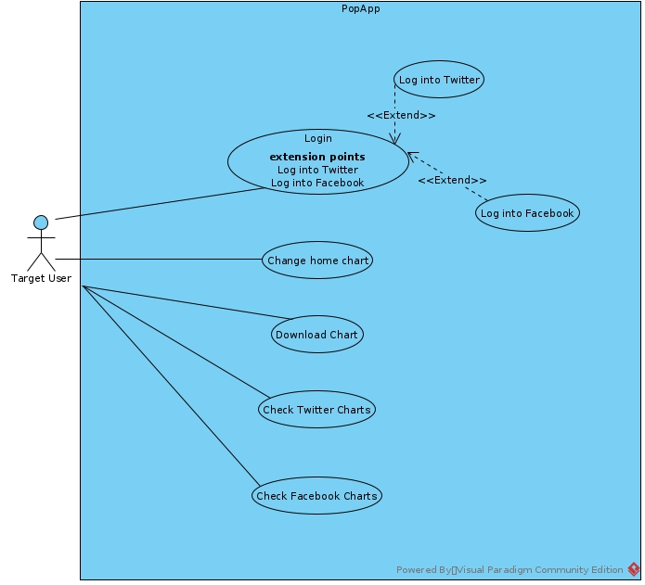

6.3.Technologies used

For this application the main program/technology used is IntelliJ’s Android Studio [5] for an easier development cycle.

Android Studio provides top notch functionality built in that helps the developer develop, right inside the IDE, XML layouts and the code itself.

Moreover the management of the external libraries is managed by the Gradle build system.

The main and only programming language used for this project is Java version 15 using the latest features of it.

In terms of testing the application, I will test in two phases. In the first phase I will test it using the built in emulator that will emulate a Google Pixel 3 environment both in the cases where there is connection to the internet and where there isn’t, the option to turn on or off the internet being present in the emulator’s options.

In the second phase I will test this application in a real world scenario using my personal phone to see if the application can “survive” the open world.

To acquire the data the application needs to fulfill it’s base goal, I am using the REST API provided by Facebook [6] and Twitter [7] that will allow me, the casual developer, to query comments and reactions from all the posts the user has made in a given interval of time. To interact with those APIs, each social network provides it’s own SDK for querying data. As such,for Twitter I will be using the Twitter SDK for Android and for Facebook I will use the Facebook SDK for Android. Both SDKs provide classes and a basic login button that encapsulates the “login to facebook/twitter” API calls.

6.4. Early proof of concept screenshots

In this subsection I will attach three images that directly link to how the three main activities the application has will look like in the grand scheme of things:

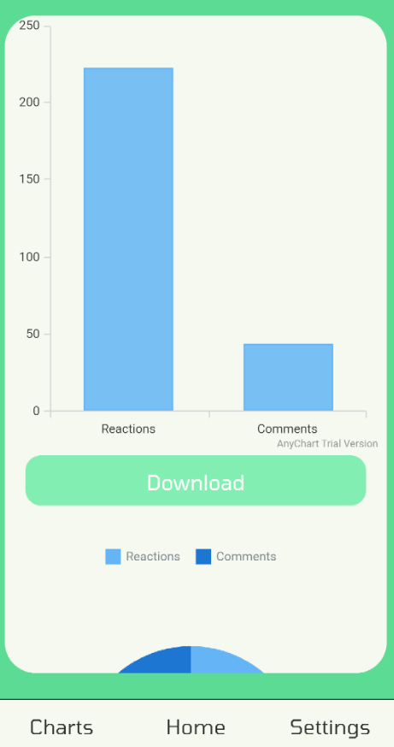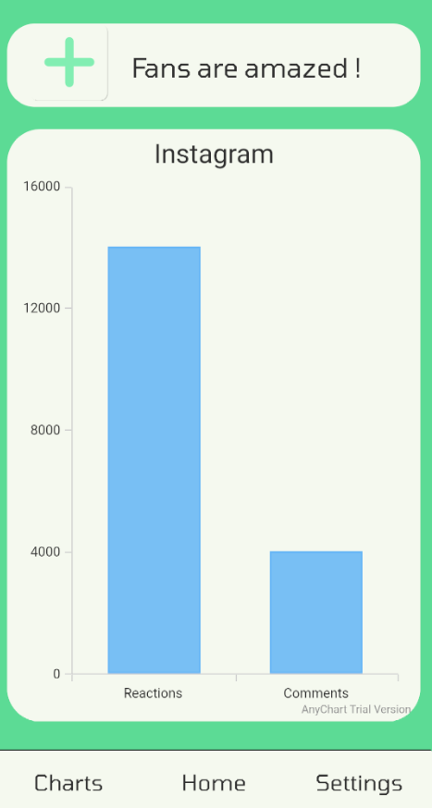

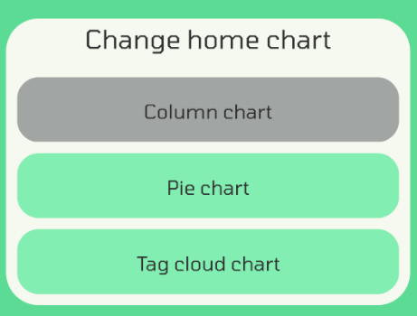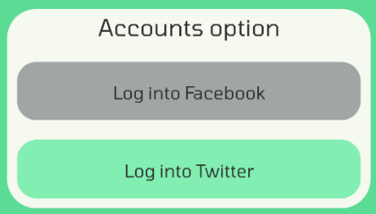

7.References

[1] https://play.google.com/store/apps/details?id=com.hootsuite.droid.full

[2] https://play.google.com/store/apps/details?id=io.iota.twitteranalytics

[3] <https://play.google.com/store/apps/details?id=com.facebook.analytics>

[4] https://github.com/AnyChart/AnyChart-Android

[5] https://developer.android.com/studio/intro

[6] https://developers.facebook.com/docs/graph-api/

[7] https://developer.twitter.com/en/docs/twitter-api